|  |
| --- |
| **LAB REPORT**    ***Submitted by***    **B. NAGA DEEPAK (RA2011030010126)**  ***Under the Guidance of***    **Ms. P. MAHALAKSHMI**  **Assistant professor, Networking and Communications**      ***In partial satisfaction of the requirements for the degree of***    **BACHELOR OF TECHNOLOGY**  **in**  **COMPUTER SCIENCE ENGINEERING**    **with specialization in cyber security**      **SCHOOL OF COMPUTING**  **COLLEGE OF ENGINEERING AND TECHNOLOGY**  **SRM INSTITUTE OF SCIENCE AND TECHNOLOGY**  **KATTANKULATHUR - 603203**  **JUNE 2022** |
| SRM INSTITUTION OF SCIENCE AND TECHNOLOGY KATTANKULATHUR-603203    **BONAFIDE CERTIFICATE**    Certified that this lab report titled **E** -**HEALTH CARE** is the bonafide work done by  **B. NAGA DEEPAK (RA2011030010126)** who carried out the lab exercises under my supervision. Certified further, that to the best of my knowledge the work reported herein does not form part of any other work.        **SIGNATURE**  Ms. P. MAHALAKSHMI  **SEPM – Course Faculty**  Assistant professor  Networking and Communications                          **ABSTRACT**  *This Health Care Management abstract will basically outline the requirement*  *and functional aspects covered in e-Health Care Management. It lists out all the*  *essential requirements for the client [Global Life Clinic] so as to provide*  *expected quality and output from the application. It also provides all info which*  *will be used by the development team to develop and design the application*  *as per workflow****.***  *Health care may be construed as a right or as a commodity. On a rights*  *perspective, society has on obligation to plan for and provide health care*  *on an equitable basis to all its members; on a commodity perspective, access*  *to health care is a matter of purchase power. Likewise, health care may be*  *delivered on a directly interactive basis or in a mediated fashion using*  *modern information technology. Further, electronic health records (EHRs)*  *are increasingly being stored in Big Data sets and expert diagnostic systems*  *are increasingly being used to evaluate EHRs. Finally, quantum technology is*  *about to replace standard computing methods. The ethical implications that*  *these have for EHRs form the subject.*  *Results of cost effectiveness analyses (CEA) studies are most useful for decision makers if they face only one constraint: the health care budget.However, in practice, decision makers wishing*  *to use the results of CEA studies may face multiple resource constraints relating to, for instance, constraints in health care inputs such as a shortage of skilled labour.*  *The presence of multiple resource constraints influences the decision rules of CEA and limits*  *the usefulness of traditional CEA studies for decision makers. The goal of this paper is to*  *illustrate how results of CEA can be interpreted and used in case a decision maker faces a*  *health care input constraint.*  *We set up a theoretical model describing the optimal allocation of the health care budget in the presence of a health care input constraint. Insights derived from that model were used to analyse a stylized example based on a decision about a surgical robot as well as a published cost effectiveness study on eye care services in Zambia.*  *Our theoretical model shows that applying default decision rules in the presence of a health care input constraint leads to suboptimal decisions but that there are ways of preserving the traditional decision rules of CEA by reweighing different cost categories. The examples illustrate how such adjustments can be made, and makes clear that optimal decisions depend crucially on such adjustments.*  We conclude that it is possible to use the results of cost effectiveness studies in the presence of health care input constraints if results are properly adjusted. |

| **CHAPTER NO** | **TITLE** | **PAGE NO** |
| --- | --- | --- |
|  |  |  |
|  | **ABSTRACT** |  |
|  | **LIST OF FIGURES** |  |
|  | **LIST OF ABBREVIATIONS** |  |
| **1** | **PROBLEM STATEMENT** |  |
| **2** | **STAKEHOLDERS & PROCESS MODELS** |  |
| **3** | **IDENTIFYING REQUIREMENTS** |  |
| **4** | **PROJECT PLAN & EFFORT** |  |
| **5** | **WORK BREAKDOWN STRUCTURE & RISK ANALYSIS** |  |
| **6**  **7**  **8**  **9**  **10**  **11**  **12** | **SYSTEM ARCHITECTURE, USE CASE & CLASS DIAGRAM**  **ENTITY RELATIONSHIP DIAGRAM**  **DATA FLOW DIAGRAM**  **SEQUENCE & COLLABORATION DIAGRAM**  **DEVELOPMENT OF TESTING FRAMEWORK/USER INTERFACE**  **TEST CASES & REPORTING**  **ARCHITECTURE/DESIGN/FRAMEWORK/IMPLE-MENTATION**  **CONCLUSION** |  |
|  | **REFERENCES** |  |
|  | **APPENDIX (CODE)** |  |

**LIST OF FIGURES**

| **FIGURE NO** | **TITLE** | **PAGE NO** |
| --- | --- | --- |
| **1**  **2**  **3**  **4**  **5**  **6**  **7**  **8**  **9**  **10** | **Work Breakdown Structure**  **TIMELINE – GANTT CHART**  **SYSTEM ARCHITECTURE DIAGRAM**  **USE CASE DIAGRAM**  **CLASS DIAGRAM**  **ER DIAGRAM**  **DATA FLOW DIAGRAM, Sequence diagram**  **Collaboration diagram**  **ARCHITECTURAL DESIGN**  **CODE SNIPPETS** |  |

**LIST OF ABBREVIATIONS:**

UML- Unified Modelling Language

WBS-Work Breakdown Structure

UI-User Interface

SWOT-Strength Weakness Opportunities Threats

ER-Entity Relationship

DFD-Data Flow Diagram

GANTT-Generalized activity Normalization Time table SSL -secure secret locker

**PROJECT TITLE:**



**Chapter 1**

Aim:

To Frame a project team, analyse and identify a Software project. To create a business case and Arrive at a Problem Statement for the E Health Care.



**Project Description:**  ***This Health Care Management application will be like in an***

***online Healthcare Management service provider with easy to use customizable***

***options. The application is accessible from anywhere for all employees or staff***

***of the hospital in private or at desktops or tablets etc. it will basically lessen the***

***manual work and improves the quality of maintaining records and other***

***information related to doctors or patients or billing etc. It reduces time***

***frame in adding any info related to hospital and thereby reduce the complexity too.***

**Problem Statement**:

It’s no secret that many physicians are unhappy with their electronic health records (EHRs). They say they spend too much time keying in data and too little making eye contact with patients. They say their electronic records are clunky, poorly designed, hard to navigate, and cluttered with useless detail that colleagues have cut and pasted to meet documentation requirements. Meanwhile, the data they really need are buried almost beyond retrieval.

Not all physicians feel this way. Two-thirds of primary care physicians say there are satisfied with their current EHRs, according to a [2018 survey by The Harris Poll](https://med.stanford.edu/content/dam/sm/ehr/documents/EHR-Poll-Presentation.pdf). But the critics have a point. Current EHRs are not well-designed to meet the needs of users. And they don’t do enough to make clinicians smarter and more efficient. This doesn’t mean we would be better off in the paper world of 10 years ago. But it does mean that EHRs need improvement.

As we think about improving them, we need to broaden the discussion of EHRs and their role. We need to reckon with the underlying causes of EHRs’ problems, how to correct them, and how to ensure that their enormous potential benefits are understood and realized.

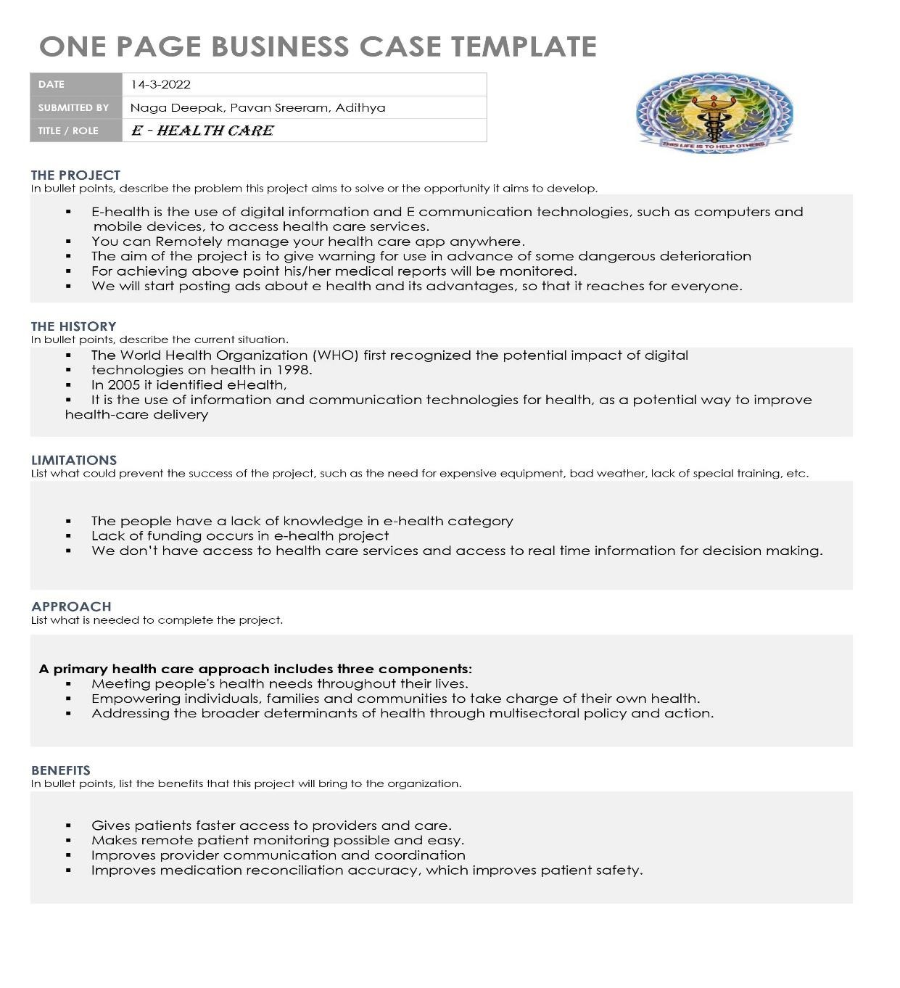

**Result:**

*Thus, the project team formed, the project is described, the business case was prepared and the problem statement was arrived.*

**Chapter 2**

**Aim:**

To identify the appropriate Process Model for the project and prepare Stakeholder and User

Description.

**Project Title: E HEALTH CARE.**

**Selection of Methodology:**

**Waterfall Model:**

**Basically waterfall model is every phase should be fully completed before moving forward to the next stage.**

**The Waterfall approach requires a lot of structure and documentation.**

**The process is divided into several stages that form a sequence:**

⦁ **Analysis**

⦁ **Design**

⦁ **Implementation**

⦁ **Testing**

⦁ **Maintenance**

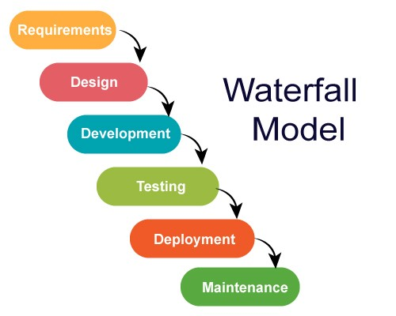

**The first stage is vital, requiring a full understanding by both developers and**

**customers of the project’s demands and scope before anything begins. The stages are relatively rigid and often follow this sequence: determine the**

**project’s requirements and scope, analyze those requirements, design, implement, test, deploy, and finally, maintain.**

**Waterfall lacks flexibility Once any modifications are needed or any errors are detected during the project, Waterfall will require a full restart. As a result, projects managed under the Waterfall method might require much more time.**

**On the other hand, it is great for ensuring that all deliverables meet expectations and it allows for easily measuring the progress since you see the full scope of the project in advance.**

**Waterfall methodology is mostly used for web development projects with a clear and predefined scope, with a fixed timeframe for project completion and few iterations or revisions.**

**Typically, one stage must be finished before the next can begin, which can help with organization and assignments. And because the full scope of the project is understood in advance, software progress can easily be measured.**

**Waterfall Methodology can be used when:**

* **Requirements are not changing frequently.**
* **Application is not complicated and big.**
* **The project is short.**
* **The requirement is clear.**
* **The environment is stable.**

**Advantages of waterfall model:**

* **This model is simple and easy to understand and use.**
* **It is easy to manage due to the rigidity of the model–each phase has specific deliverables and a review process. These phases are processed and completed one at a time. Phases do not overlap.**

**Stakeholder and User Description:**

|  |  |  |  |  |
| --- | --- | --- | --- | --- |
| **Stakeholder**  **Name** | **Activity/ Area /Phase** | **Interest** | **Influence** | **Priority**  **(High/**  **Medium/**  **Low)** |
| **Owner** | Achieve targets | High | High | 1 |
| **Team members** | Retain and upgrade skills New product  excitement | High | High | 2 |
| **Project Manager** | Lead the team in every aspect Accountable for entire project scope, team, success, and failure | High | High | 2 |
| **Resource Manager** | Managing the required resources are available according to project needs and budget | Medium | Medium | 3 |
| **End users** | Uses software and Provides feedback | Low | Low | 4 |

**Result:**

Thus the Project Methodology was identified stakeholders were described.

**Chapter 3**

**Aim**

To identify the system, functional and non-functional requirements for the project.

**PROJECT TITLE:**



**System Requirements**

**User interfaces (GUI design):**

*Input from the user will be via keyboard input and mouse point and click. The user will navigate through the software by clicking on icons and links. The icons will give appropriate responses to the given input.*



**Hardware interfaces***:*

*All components able to be executed on personal computers with Windows OS platforms and other platforms like Linux, Unix.*

*Operating system: window*

*Hard disk :40 GB*

*RAM: 256 MB*

*Processor: Pentium (R)Dual-core CPU* **Software:**

*All the interfaces will be ASPX pages running within the internet browser. The SMS must integrate with the DB though SQL Interface. The system will be hosted in a web server running on Windows Server 2005.*

* *Java language*
* *Net beans IDE 7.0.1*
* *MS SQL server 2005*

*Communication protocols and interfaces*

* *This project can compatible with all platforms. Connections to the system will be over TCP/IP connection, project supports all types of web browsers. I have used database so my system can work offline.*

**Functional Requirements**

1. *There should be a web portal for user to access his /her info.*
2. *In web portal there should be Constant update and notification in government’s e-health policy*
3. *We need user to register, verify and login to e-health account*
4. *Data Entry should be done by the server*
5. *We need to user previous health records for monitoring his health condition*
6. *Filtration should be done in user provided data for deletion to avoid duplication of data provided by user.*
7. *Proper maintenance is required.*





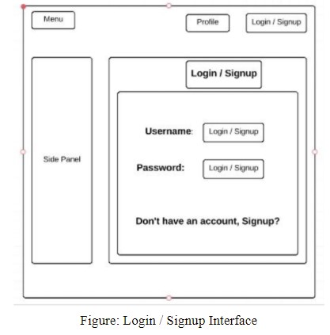

**Non-Functional Requirements**

* *The system user interface should be easy to use and learn in every aspects.* • *The new users should get used to in the system as fast as possible*
* *The web page shall be available for users 24/7.*
* *The system should provide good quality.*
* *User data should be secured from unauthorized access.*
* *There should be an option for complaint service for user*
* *We should increase hardware according to usage of server.*

**Result**

Thus, the requirements were identified and accordingly described.

**Chapter 4**

**Aim**

To Prepare Project Plan based on scope, Calculate Project effort based on resources, Find Job

roles and responsibilities

1. Project Management Plan

Describe the key issues driving the project. **[Min 3 Focus Areas]**

|  |  |
| --- | --- |
| **Focus Area** | **Details** |
| Schedule  Management | Sorting a UI DESIGN And mocking up a site  converting the mock-up site to a fully responsive website connecting frontend with the backed and establishing database connection  Beta testing  Correcting the flaws  Launching the site |
| Quality  Management | * Simple User Interface * Using high-end database for better response time * Rating based formulation for content quality |
| Resource  Management | People and skills required:   * Full Stack Developer – Frontend and backend development * Designer – Responsive web designing * Administrator – DBMS and application monitoring     Finance: Budget Required  14,00,000  Physical: Facilities, IT infrastructure   * Server infrastructure |
| Scope  Management | * This project can be used by common people freely and with ease * Many doctors and students who want to help people and want to raise awareness can do it through this application are required   ⚫ |

1. Estimation

2.1. Effort and Cost Estimation

|  |  |  |  |  |
| --- | --- | --- | --- | --- |
| **Activity Description** | **Sub-Task** | **Sub-Task**  **Description** | **Effort (in hours)** | **Cost in INR** |
| Design the homepage | Header | To navigate to different menu | 3 | 1500 |
| Login credentials | To design and develop | 3 | 1500 |
| Captcha verify |  |  |
| Resource page | 5 | 2500 |
| Data entry of patient | 4 | 2000 |
| Basic library Search | 2 | 1000 |
| Icon graphical design | 1 | 500 |
| Database connection establishment | Data flow control from server to website | Query for data ingestion and data extraction | 7 | 3500 |
| Testing | Front-end testing | Authentication alerts, error alert and notifications alert | 2 | 1000 |
| Back-end testing | To authenticate user information To check navigation  Dialogue control | 2 | 1000 |

# **2.2. Infrastructure/Resource Cost [CapEx]**

|  |  |  |  |
| --- | --- | --- | --- |
| **Infrastructure Requirement** | **Qty** | **Cost per qty** | **Cost per item** |
| Laptop | 2 | 80,000 | 1.60 lakh |
| Server Infrastructure | 1 | 3.5 lakhs | 3.5 lakhs |

# **2.3. Maintenance and Support Cost [OpEx]**

|  |  |  |  |  |
| --- | --- | --- | --- | --- |
| **Category** | **Details** | **Qty** | **Cost per qty per annum** | **Cost per item** |
| People | * System and DB admin * Tester * Designer * Developer | 3 | 1,50,000 | 4,50,000 |
| License | * Operating System * Database * Design software | 5 | 10,000 | 50,000 |
| Infrastructures | * Server * Storage | 2 | 30,000 | 60,000 |

1. Project Team Formation
   1. Identification Team members

|  |  |  |
| --- | --- | --- |
| **Name** | **Role** | **Responsibilities** |
| Naga Deepak | Key Business User | Data control and monitoring of business |
| Sanbeet | Project Manager | Manage the project |
| Naga Deepak | Designer | Design the user experience |
| Sanbeet | Frontend Developer | Develop user interface |
| Pavan sreeram | Backend Developer | Design, Develop and Unit Test Services/API/DB |
| Pavan Sreeram | Cloud Architect | Design the cost effective, highly available  and scalable architecture |
| Naga Deepak  Pavan Sreeram | Tester | Define Test Cases and Perform Testing |

* 1. Responsibility Assignment Matrix

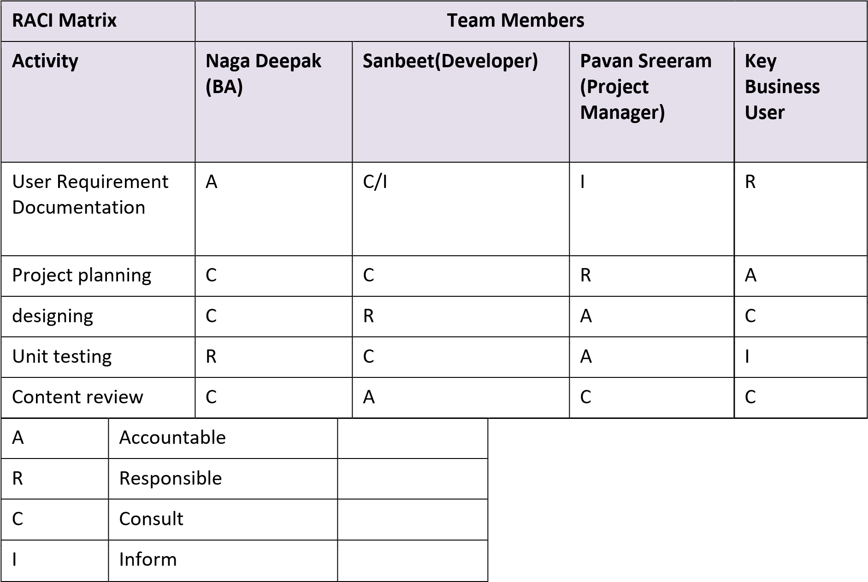

Result:

Thus, the Project Plan was documented successfully

**CHAPTER -5**

**Aim**

To Prepare Work breakdown structure, Timeline chart and Risk identification table

**WBS**



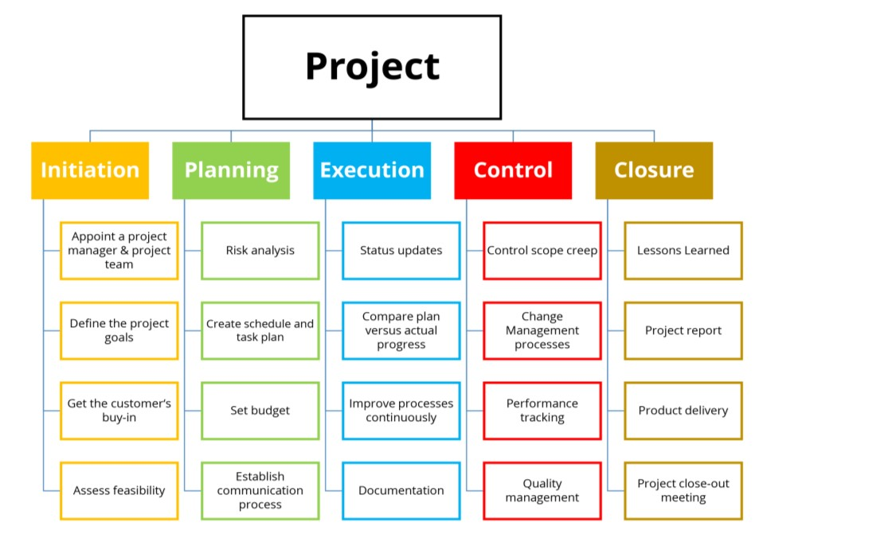

1.Project

1.1. Initiation

1.1.1. Appoint a project manager and team

1.1.2. Define the project goals

1.2. Planning

1.2.1. Risk analysis

1.2.2. Set Budget

1.3. Execution

1.3.1. Status Update

1.3.2. Documentation

1.4. Control

1.5. Closure

### *TIMELINE – GANTT CHART*



**RISK ANALYSIS – SWOT & RMMM+**

**SWOT ANALYSIS**

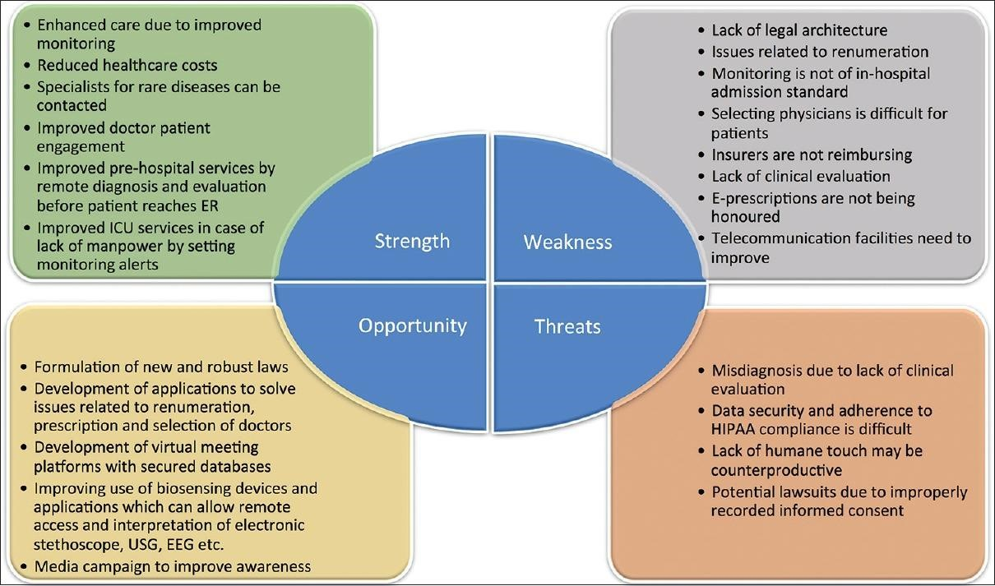

***RMMM*** - ***Risk Mitigation, Monitoring, and Management***



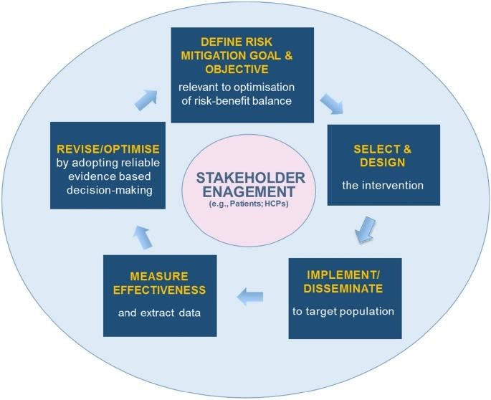

**Risk management framework**

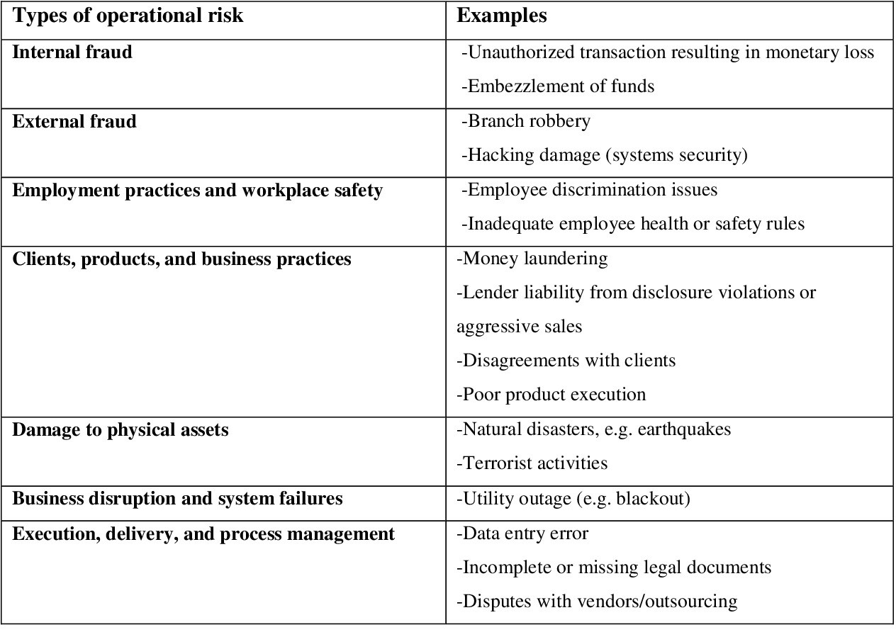



Result:

Thus, the work breakdown structure with timeline chart and risk table were formulated successful



**Chapter 6**

**Aim**

To Design a System Architecture, Use case and Class Diagram

**SYSTEM ARCHITECTURE**

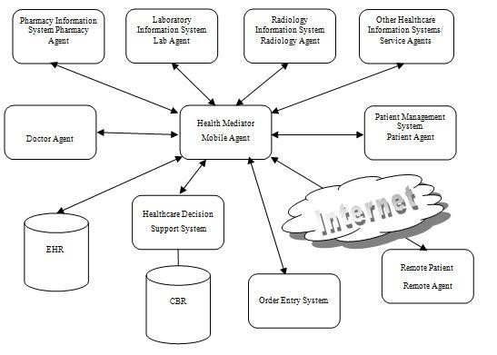

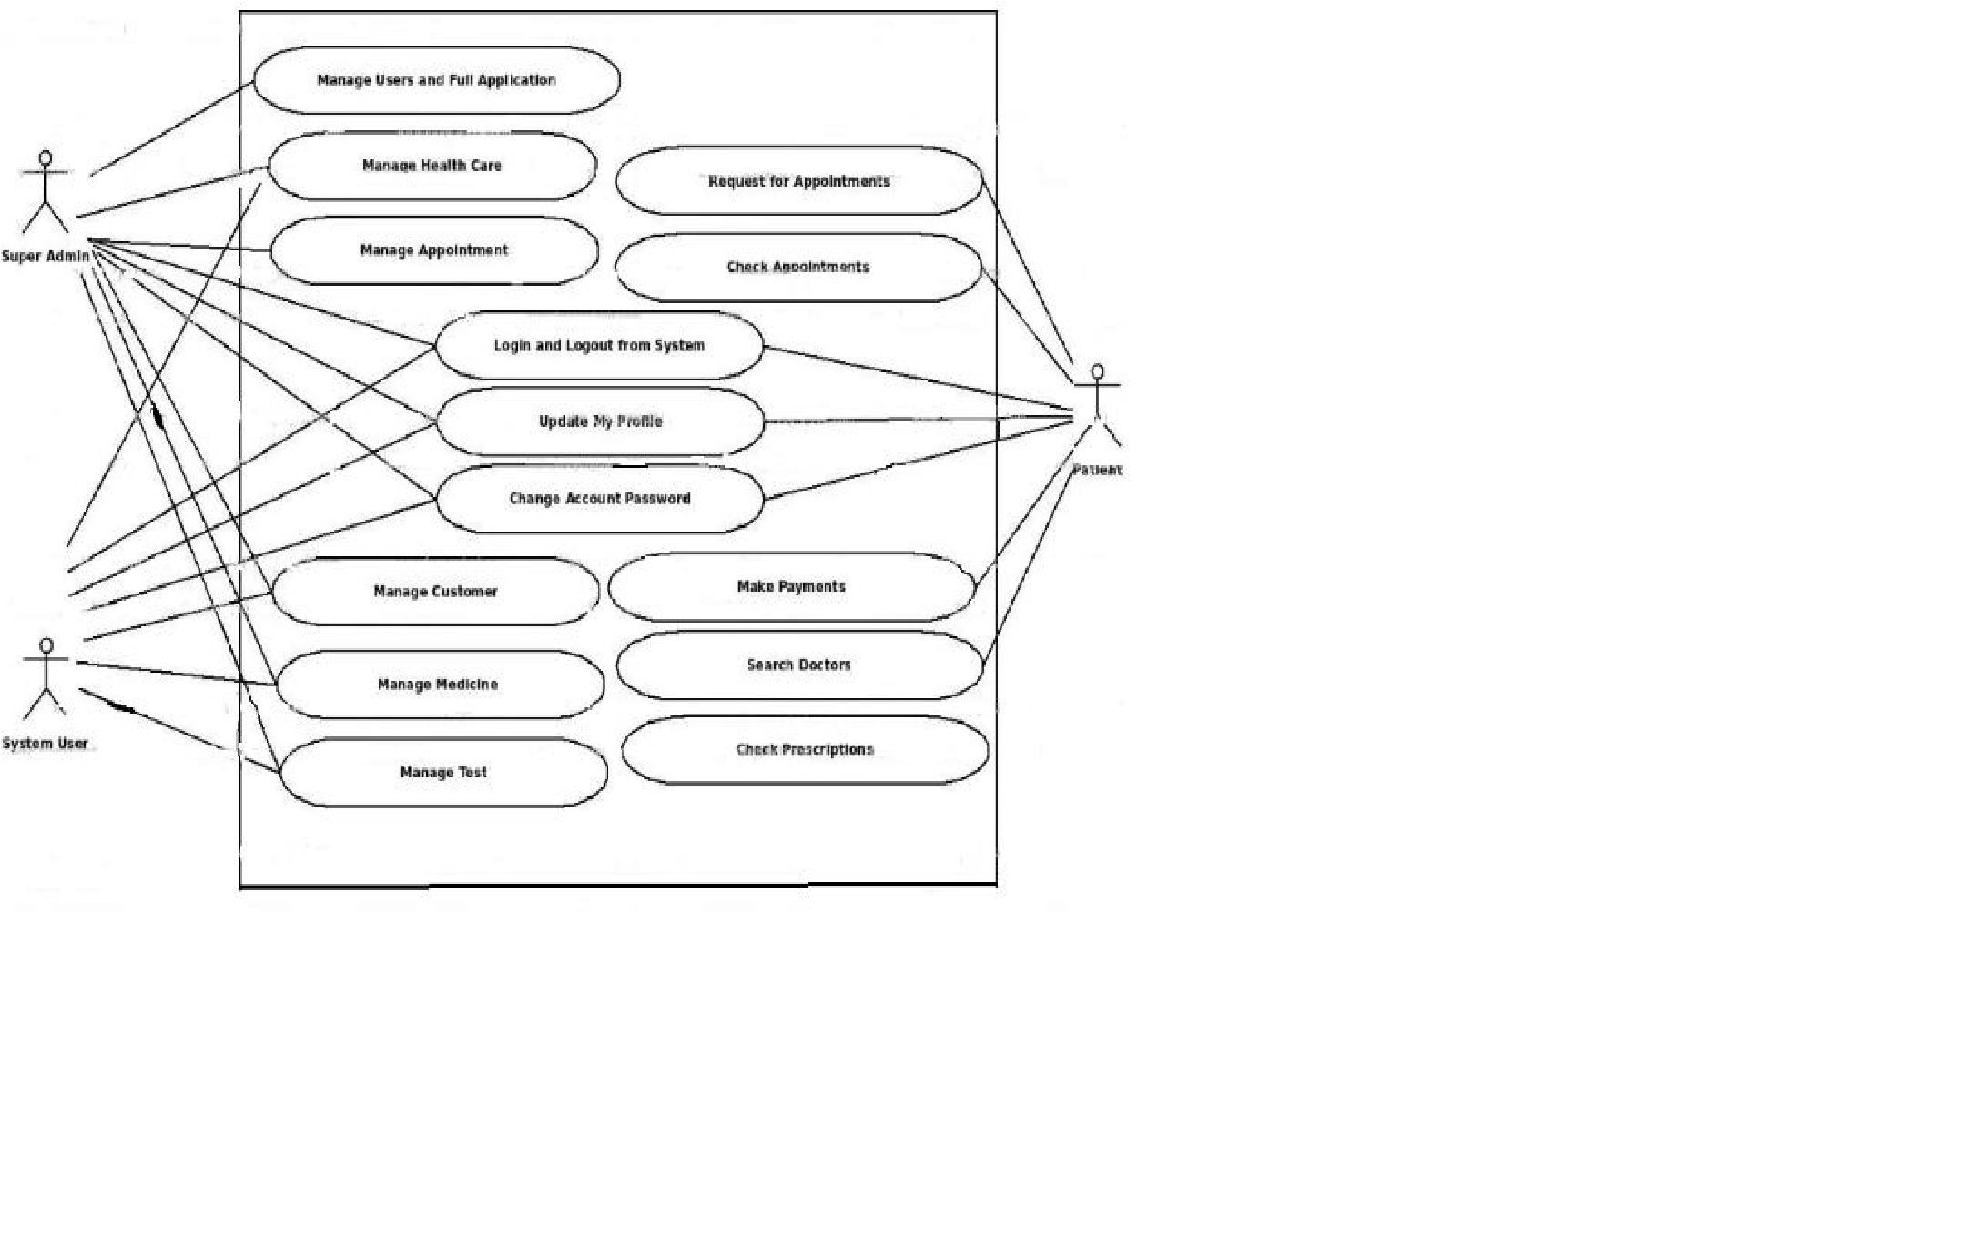

**CLASS DIAGRAM –**

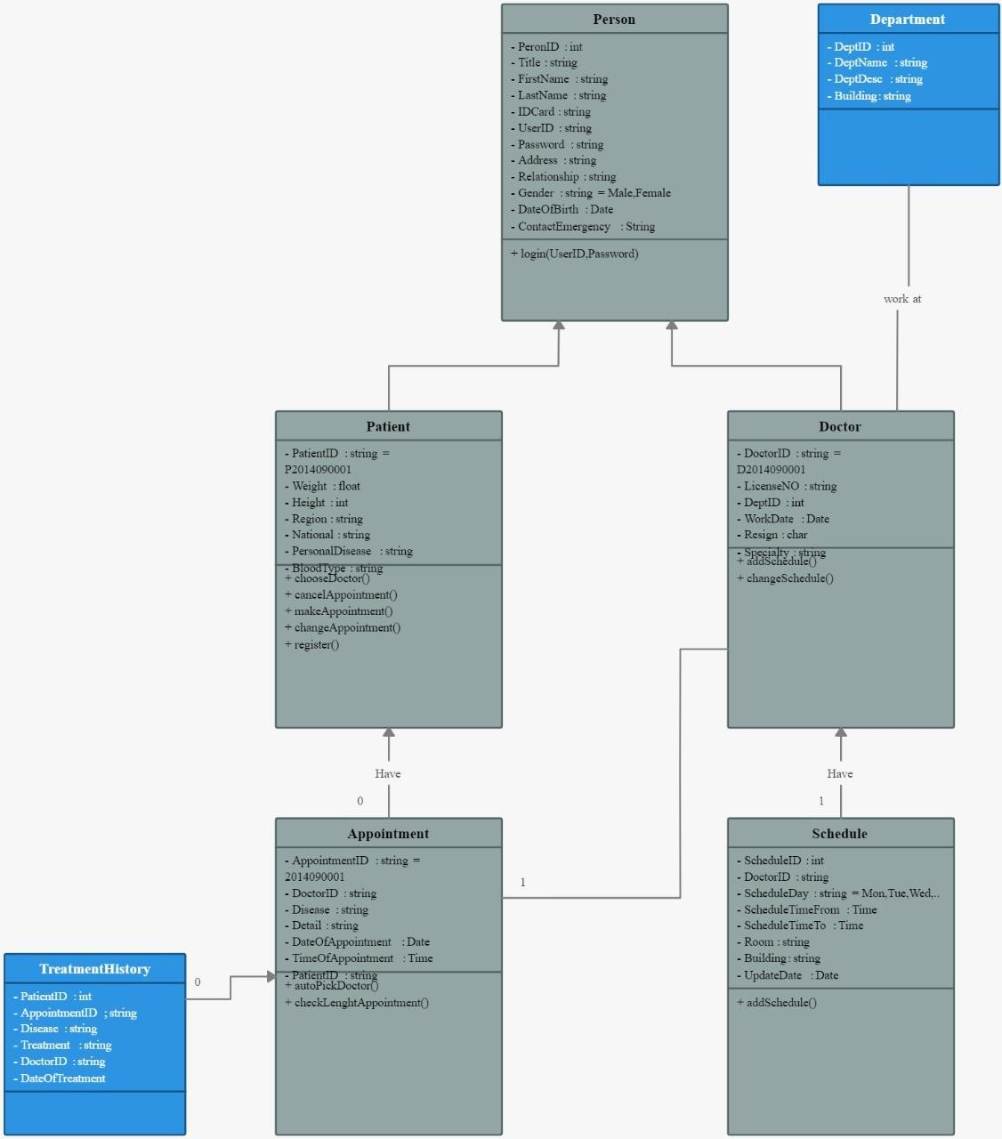

Result:

Thus, the system architecture, use case and class diagram created successfully.

**CHAPTER -7**

**Aim**

To create the Entity Relationship Diagram

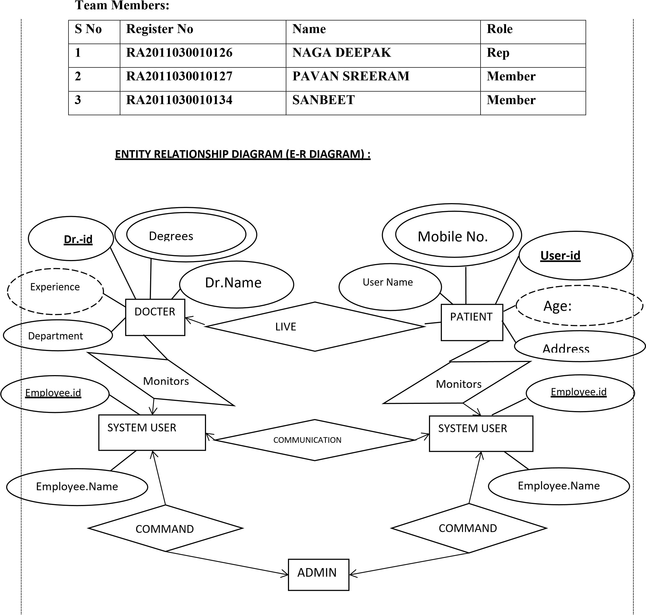Result: Thus, the entity relationship diagram was created successfully. 



**CHAPTER -8**

**Aim**

To develop the data flow diagram up to level 1 for the <E-HEALTH CARE>

### Data Flow Diagram

The DFD takes an input-process-output view of a system. That is, data objects flow into the software, are transformed by processing elements, and resultant data objects flow out of the software. Data objects are represented by labeled arrows, and transformations are represented by circles (also called bubbles). The DFD is presented in a hierarchical fashion. That is, the first data flow model (sometimes called a level 0 DFD or context diagram) represents the system as a whole. Subsequent data flow diagrams refine the context diagram, providing increasing detail with each subsequent level.

The data flow diagram enables you to develop models of the information domain and functional domain. As the DFD is refined into greater levels of detail, you perform an implicit functional decomposition of the system. At the same time, the DFD refinement results in a corresponding refinement of data as it moves through the processes that embody the application.

A few simple guidelines can aid immeasurably during the derivation of a data flow diagram:

1. Level 0 data flow diagram should depict the software/system as asingle bubble;
2. Primary input and output should be carefully noted;
3. Refinement should begin by isolating candidate processes, data objects, and data stores to be represented at the next level;
4. All arrows and bubbles should be labeled with meaningful names;
5. Information flow continuity must be maintained from level to level and
6. One bubble at a time should be refined. There is a natural tendency to overcomplicate the data flow diagram. This occurs when you attempt to show too much detail too early or represent procedural aspects of the software in lieu of information flow. **DFD Level 0**

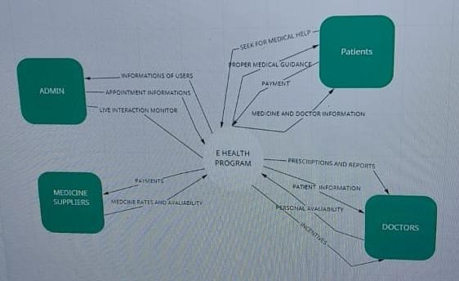

**DFD Level 1**

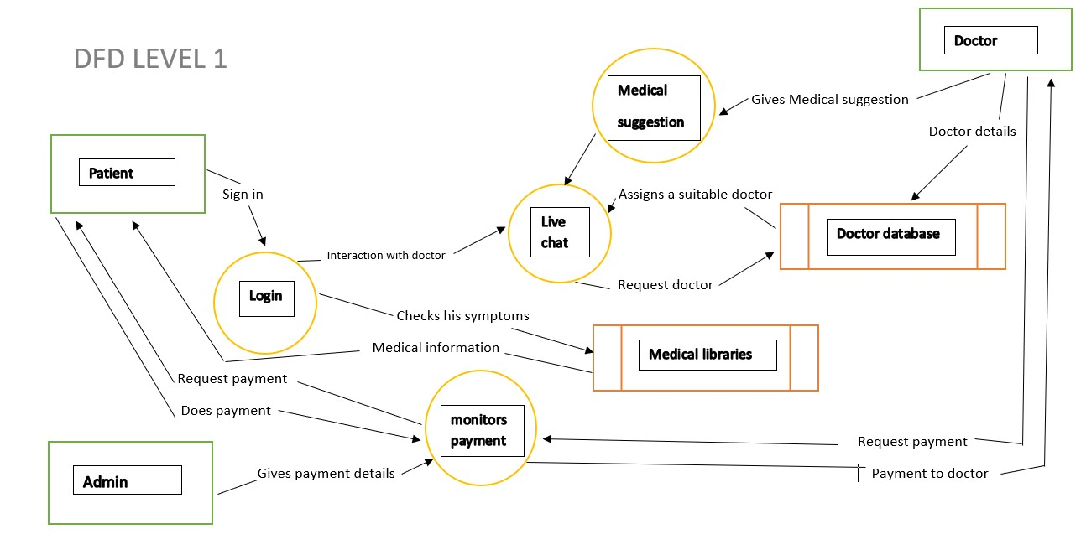

Result:

Thus, the data flow diagrams have been created for the E-HEALTH CARE.

**CHAPTER -9**

**Aim**

To create the sequence and collaboration diagram for the E-HEALTH CARE

Sequence diagram

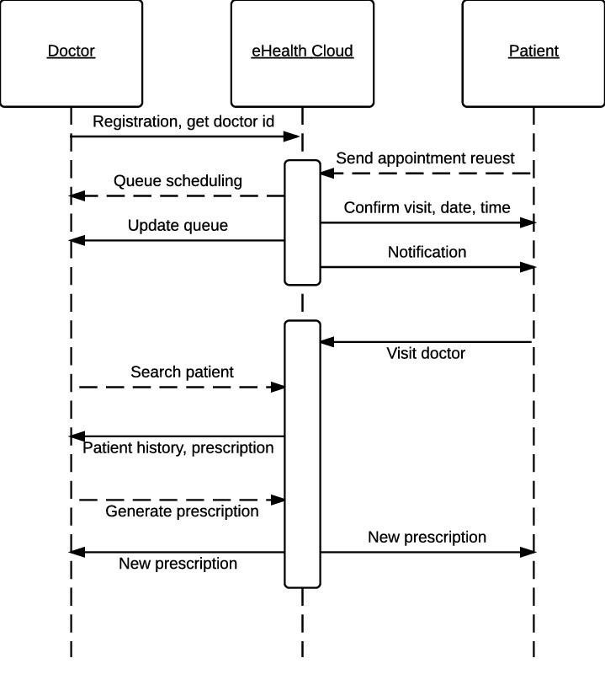

# Collaboration Diagram

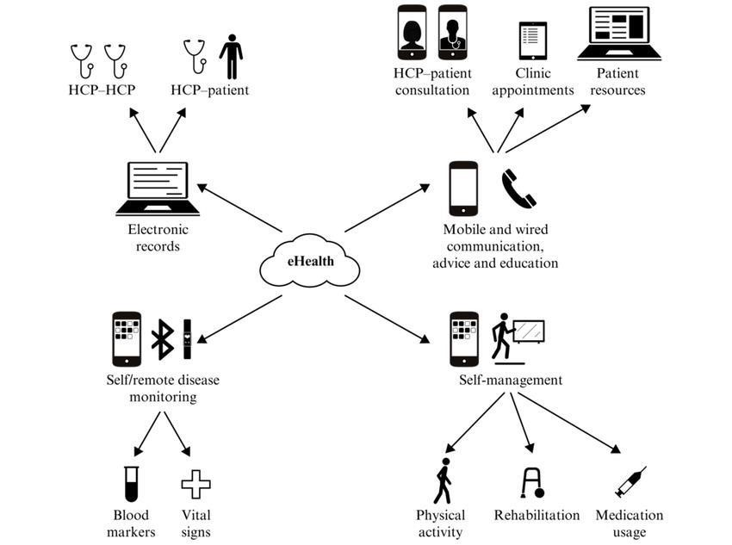Result:

Thus, the sequence and collaboration diagrams were created for the E-health

**CHAPTER -10**

## 

**Aim**

To develop the testing framework and/or user interface framework for e health care software.

Here we have provided our test plan which checks each part of our user interface attached.

**Test Plan**

**Scope of testing**

Functional Requirements like Login tab, Mandatory Patient Information (Database), Report Generation, Registration Process of patients all are needed to be tested with various methodologies defined in the table below.

Non-Functional requirements like Security, Maintainability, Back-Up, Errors is also tested except performance testing and attractive/easy to use UI.

**Types of Testing, Methodology, Tools**

|  |  |  |  |
| --- | --- | --- | --- |
|  | Category | Methodology | Tools Required |
| Functional  Requirements | Login tab | Automation | Selenium |
| Mandatory Patient  Information  (Database), | Manual | Jira |
| Report Generation | Automation | Selenium |
| Registration  Process of patients | Manual | Jira |
| Non- Functional  Requirements | Security | Automation | Selenium |
| Maintainability,  Back-Up, Errors | Automation | Selenium |

**Executive summary**

The objective is to test the application interface and each module related to it, which includes user interface, and functionality of each module. The approach used in our project is modular testing framework.

Primary reasons why modular framework is the best solution for our project is modular test design helps testers to focus on isolated modules which can be later integrated and can be driven by master driver script. All these are achieved with the help of common functional libraries which are used while developing scripts for the module. Modular automation framework follows abstraction so if we need to change the test data, we can just update the scripts of modules.

Advantages of modular framework: -

* If a particular module is impacted the test scripts developed for that module only needs to be changed.
* It is easily expandable
* Modular framework is easy to maintain

As a result, there's less maintenance effort because by updating the corresponding module all test cases reusing it are also up-dated in one go.

**UserInterface:**  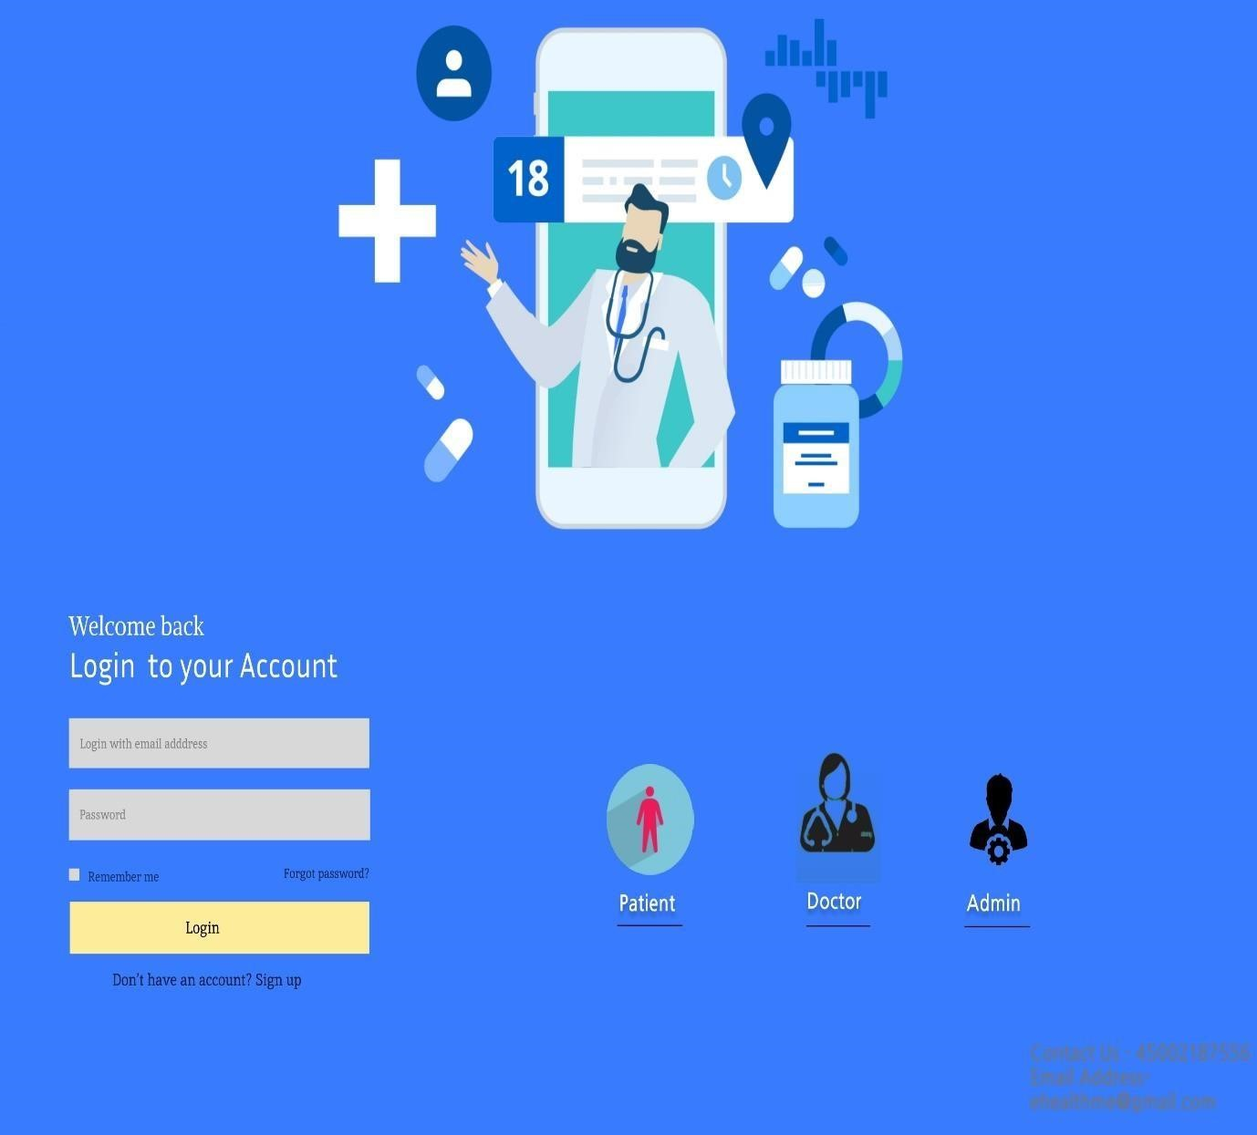

**Result:**

Thus, the testing framework/user interface framework has been created for the E health care software.

**CHAPTER -11(A)**

**Aim**

To develop the test cases manual for the E-HEALTH CARE

**Test Case** **Functional Test Cases**



|  |  |  |  |  |  |  |  |  |
| --- | --- | --- | --- | --- | --- | --- | --- | --- |
| **Test**  **ID**  **(#)** | **Test**  **Scenario** | **Test Case** | **Execution Steps** | | **Expected**  **Outcome** | **Actual**  **Outcome** | **Status** | **Remarks** |
| 1. | User  Registration | Mobile Number  verification | 1. User clicks on User Registration link 2. Enter the mobile Number   the text box   1. Enter password 2. Click on log in 3. Enter the OTP for number   verification Click on verify to go  for next page | | User should be Logged in and taken to the main page for entering  more user details | User is logged in and redirected to profile page for entering his/her and details | Pass | success |
| 2. | User details | to view profile | 1.  2. | Add name,  Address and Basic info of  user Add any medical documents present(opt) | User is redirected to main page of the application | User is redirected to main page of the application | Pass | success |
| 3. | Connection establishment Between doctor and patient | Connection  Faults/poor internet | 1.  2.  Then co good. | User has good internet Doctor has good internet nnection is | User is connected to assigned doctor and is showed in page | User is connected to doctor | Pass | success |

**Non-Functional Test Cases**



|  |  |  |  |  |  |  |  |
| --- | --- | --- | --- | --- | --- | --- | --- |
| **Test**  **ID**  **(#)** | **Test Scenario** | **Test Case** | **Execution**  **Steps** | **Expected**  **Outcome** | **Actual**  **Outcome** | **Status** | **Remarks** |
| 1 | performance | Test page loading speed | Load one page to another | load in less than 2 sec | load in around 5-10 sec | pass | Depends on the Users system and internet speed |
| 2 | Data- updation | Data update to the database | Enter any details to post to database | Data updated  Successfully to database | Data updated  Successfully to database | pass | If the file is  not selected appropriately or is not in correct format. |
| 3 | User Interface | checking the responsiveness, the webapp for all the devices | Try out web app in different devices resolution | App is responsive and align accordingly to the devices | App is responsive and align accordingly to the devices | pass | Required any browser for this software |
| 4. | Security testing | To identify the threats in the system and measure its potential vulnerabilities | By automated software to scan a system  against known  vulnerabiliy signatures. | App is good to use and no security breach occurred | App is responsive and no error occurred | pass | If there is any issue report can be done by user |

**Result:** Thus, the test case manual has been created for the e-health

**CHAPTER -11(B)**

**Aim**

To prepare the manual test case report for the E - Health Care.

|  |  |  |
| --- | --- | --- |
| **Category** | **Progress Against Plan** | **Status** |
| Functional Testing | Green | Completed |
| Non-Functional Testing | Amber | In-Progress |

|  |  |  |
| --- | --- | --- |
| **Functional** | **Test Case Coverage (%)** | **Status** |
| Front End | 60% | In Progress |
| User Reservation | 40% | In Progress |
| Data Base | 50% | In Progress |
| Back End | 40% | In Progress |

**Result**:

Thus, the test case report has been created for the E - Health Care.

**CHAPTER -12**

**Aim**

To provide the details of architectural design/framework/implementation

**ARCHITECTURAL DESIGN, FRAMEWORK AND IMPLEMENTATION :**

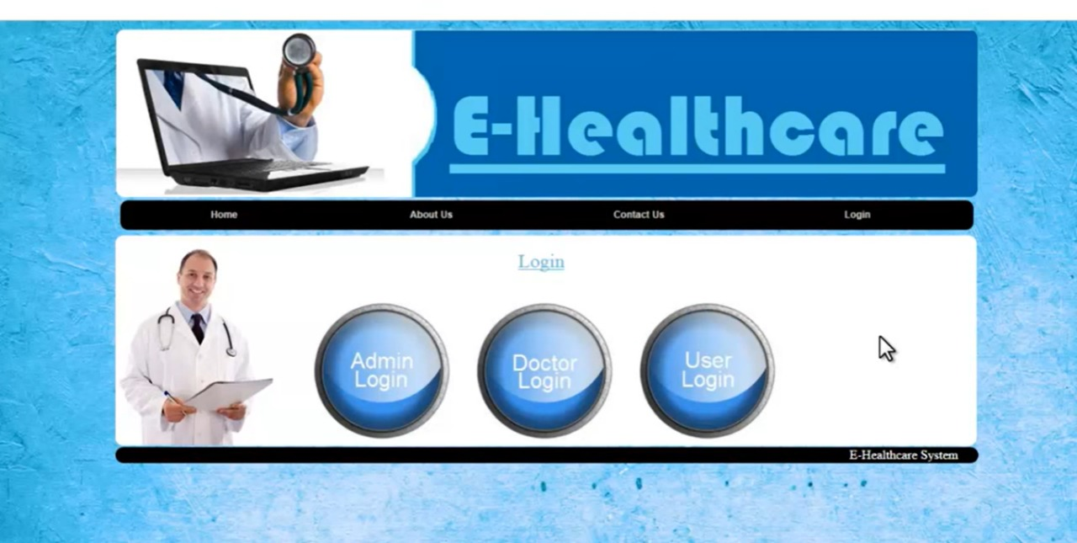

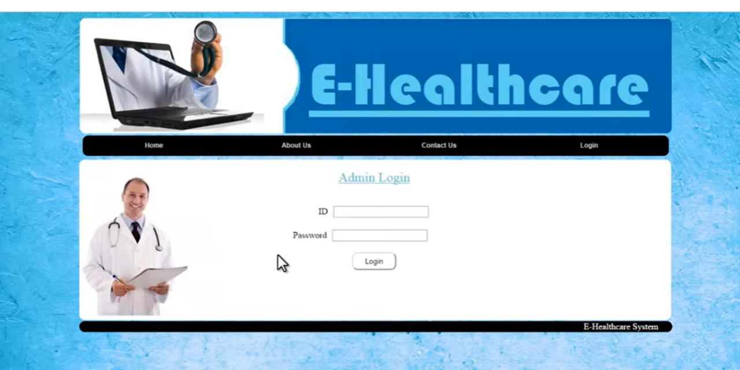

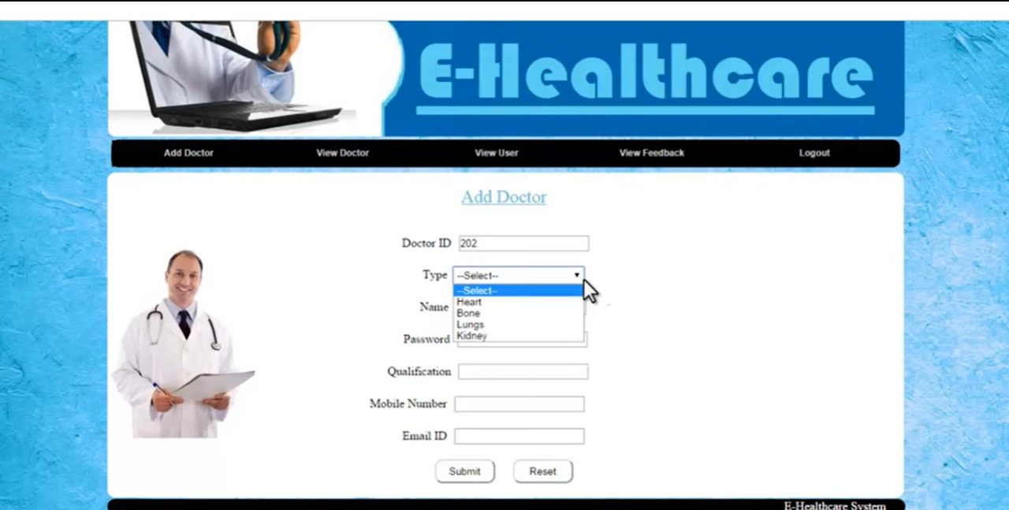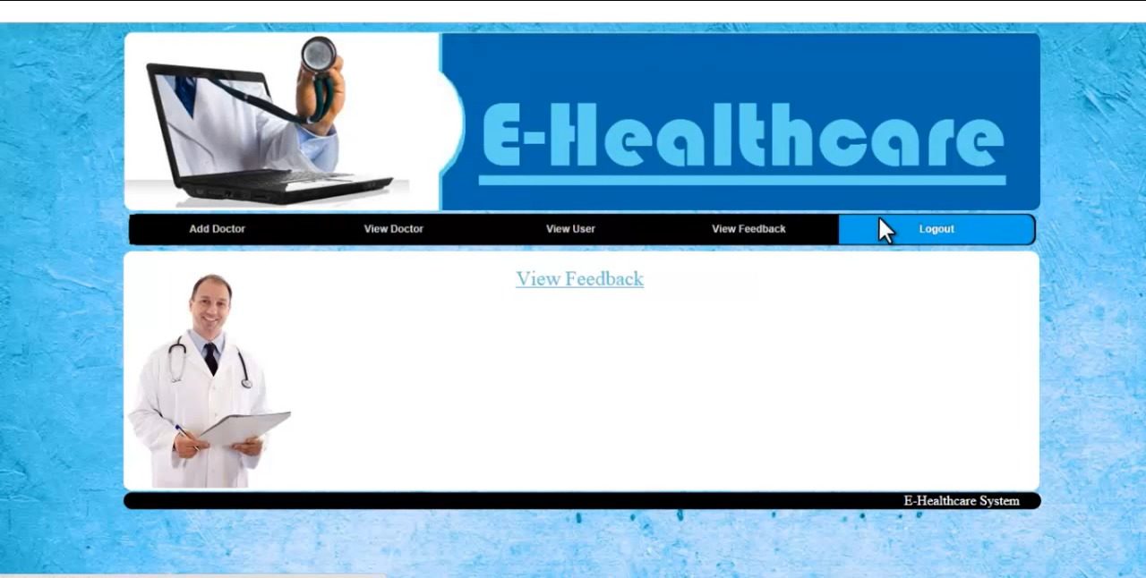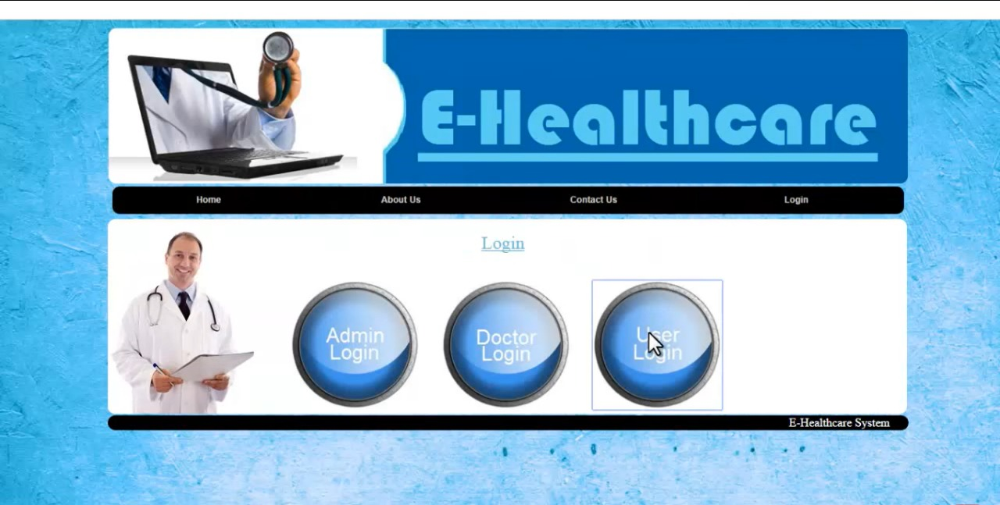

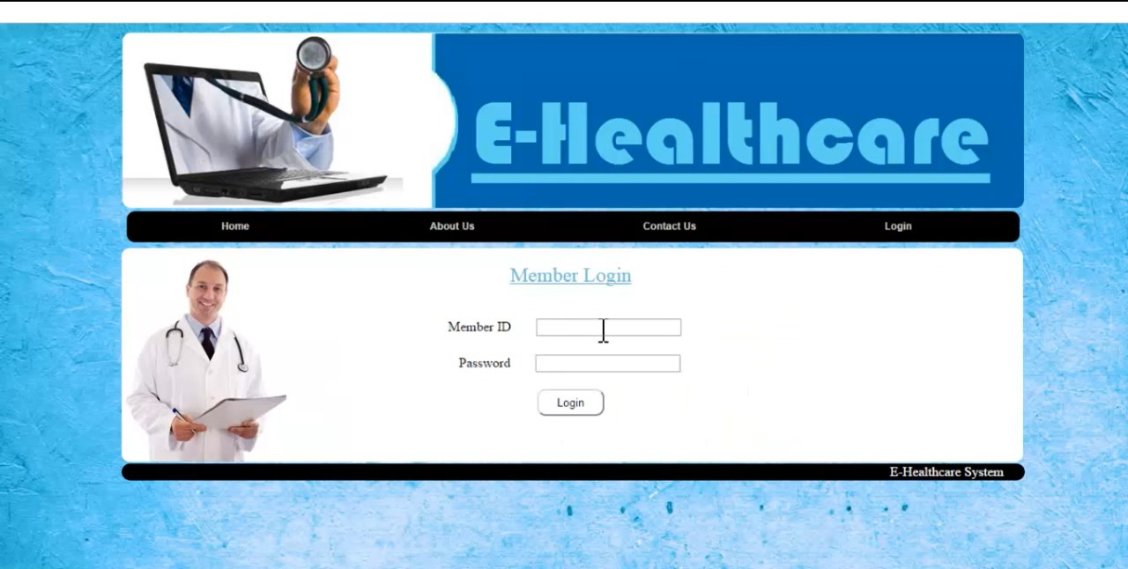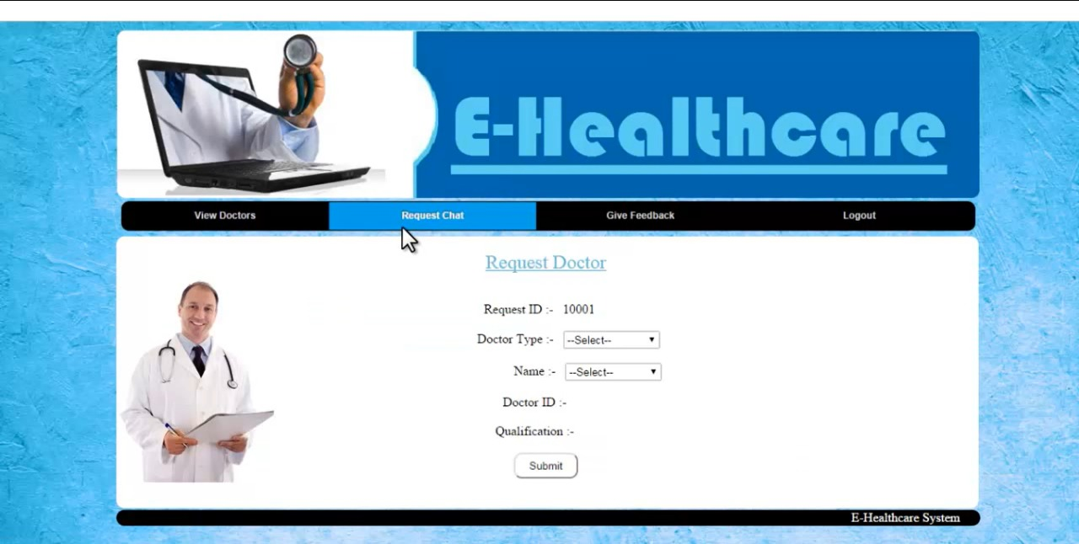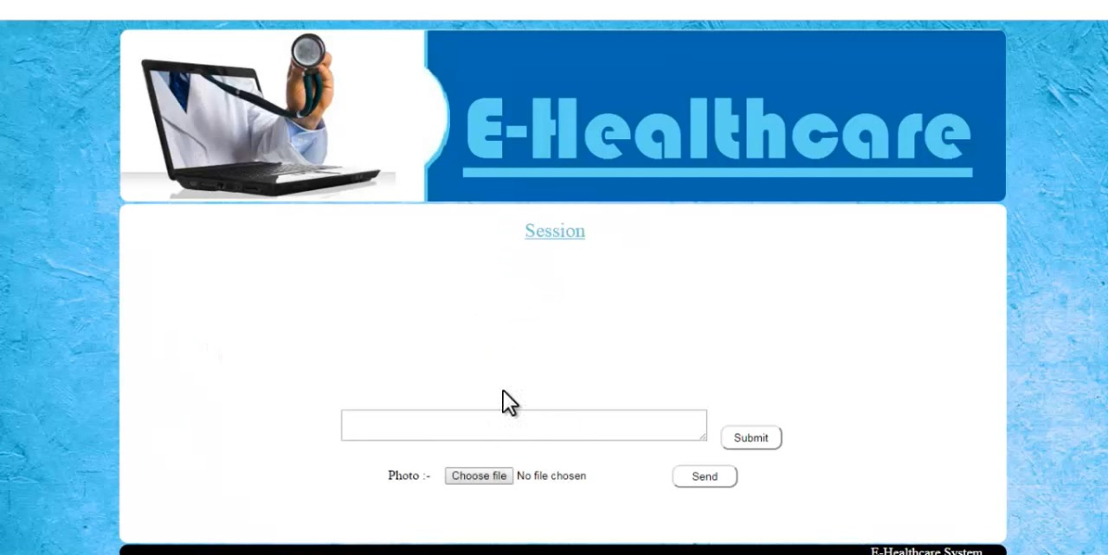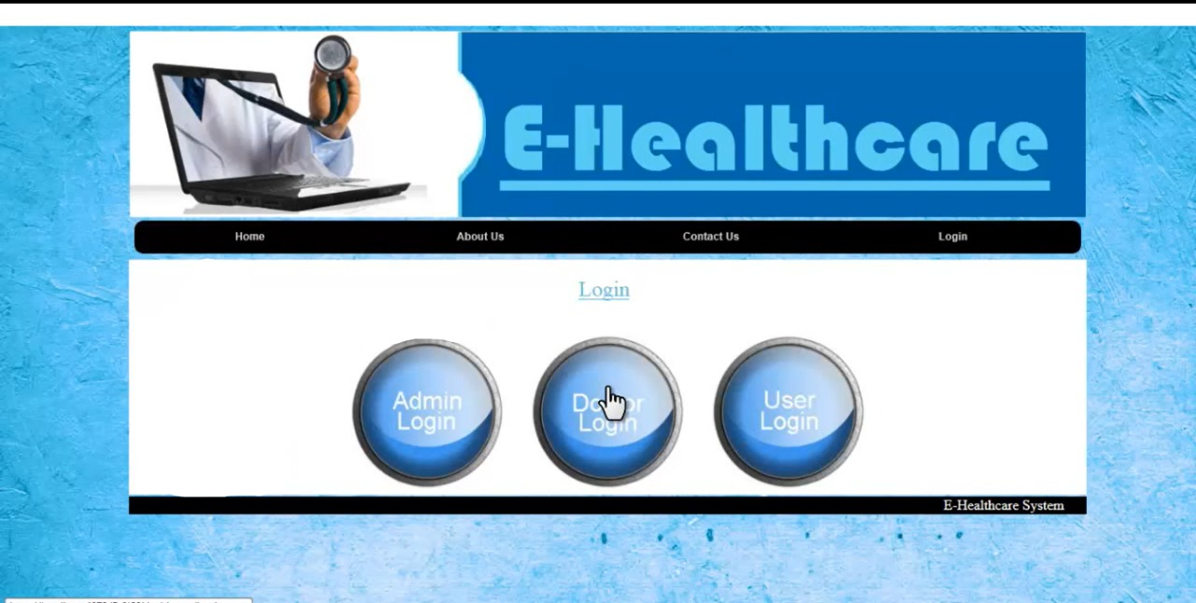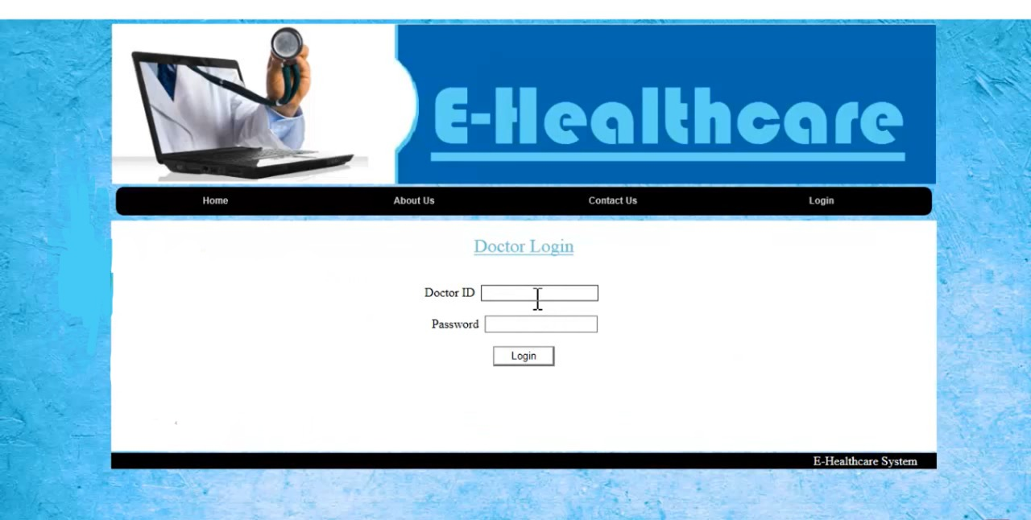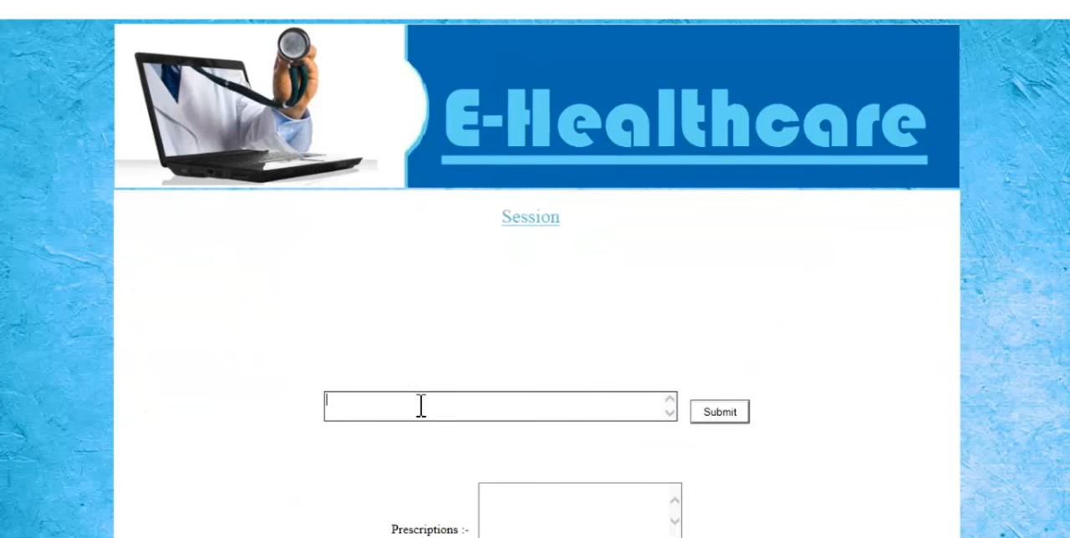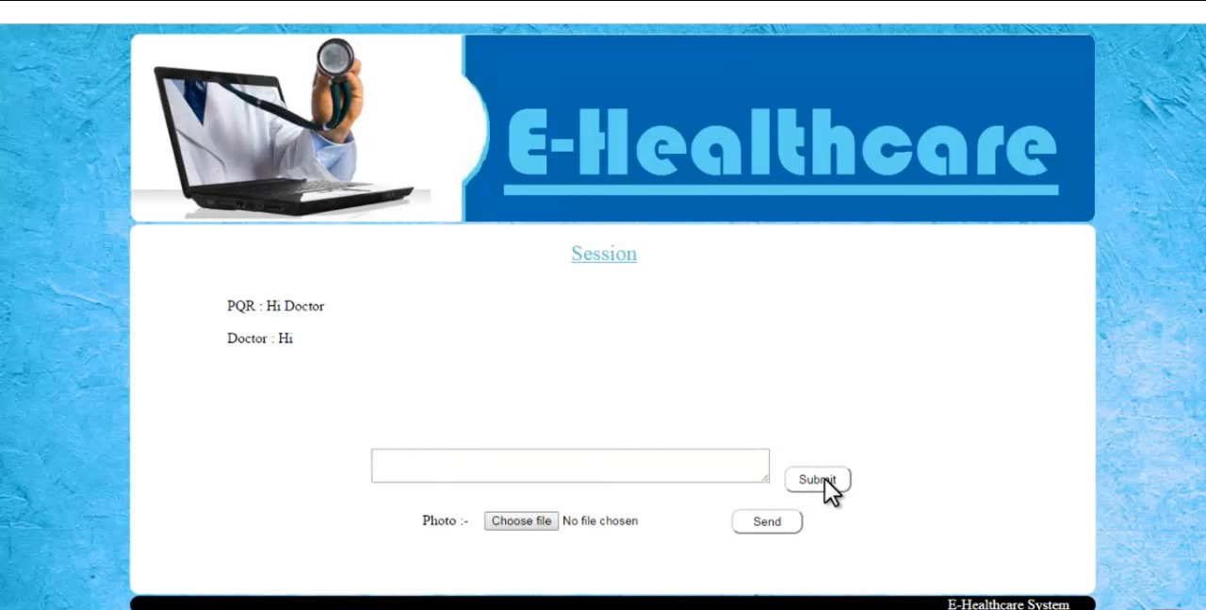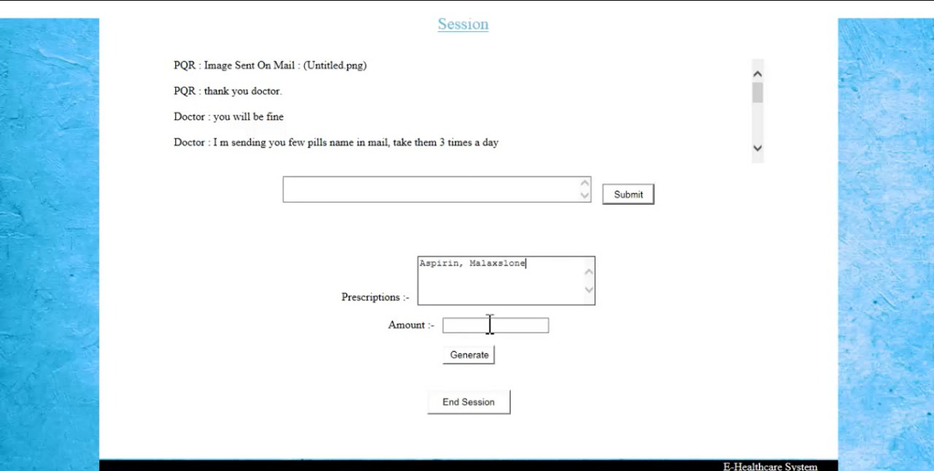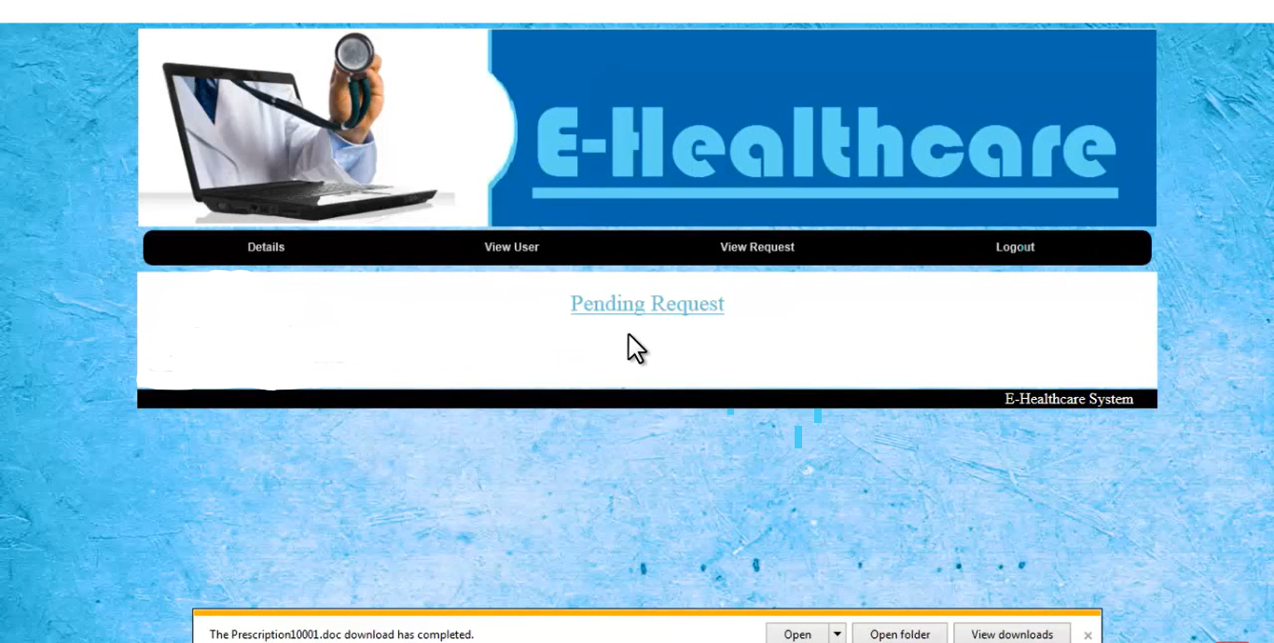

**CODE MODULES:**

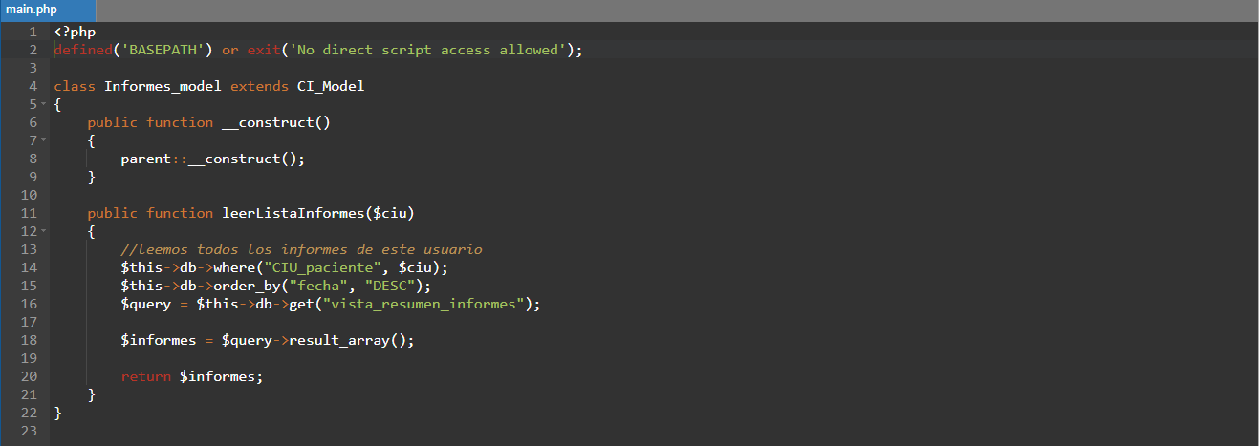

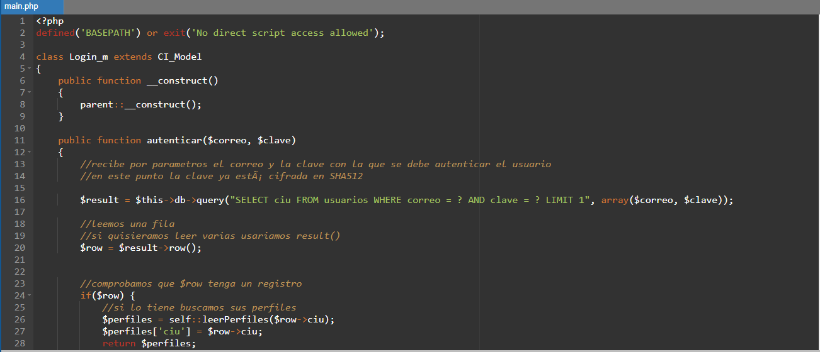

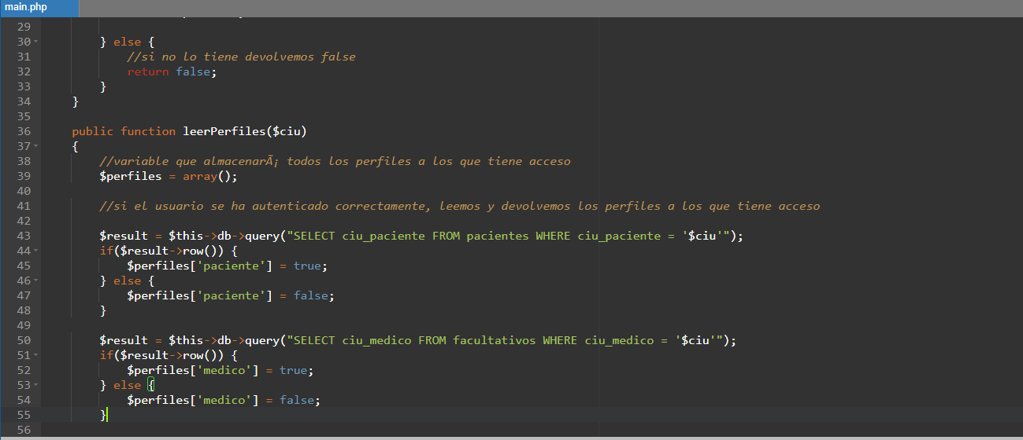

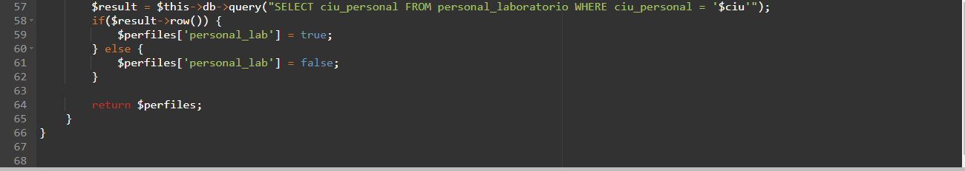

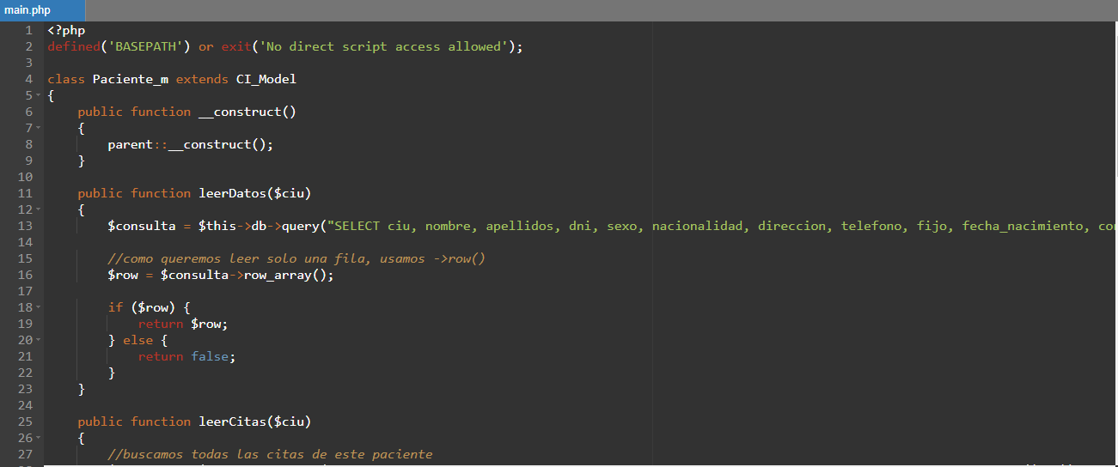

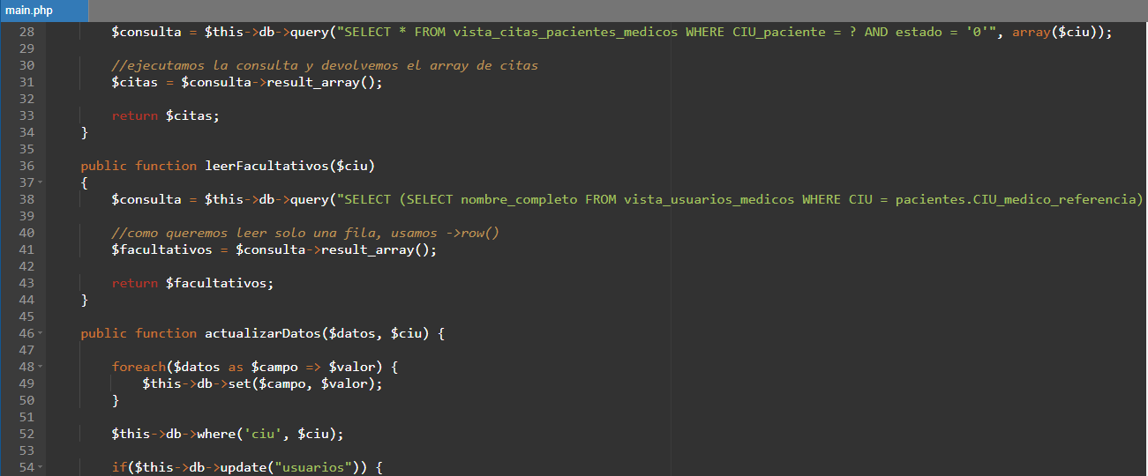

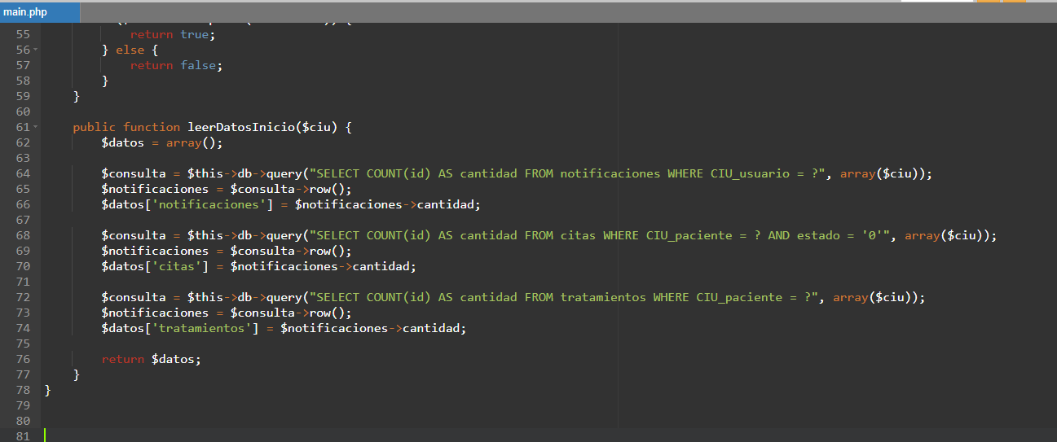

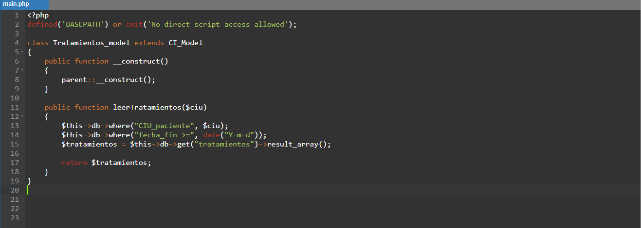

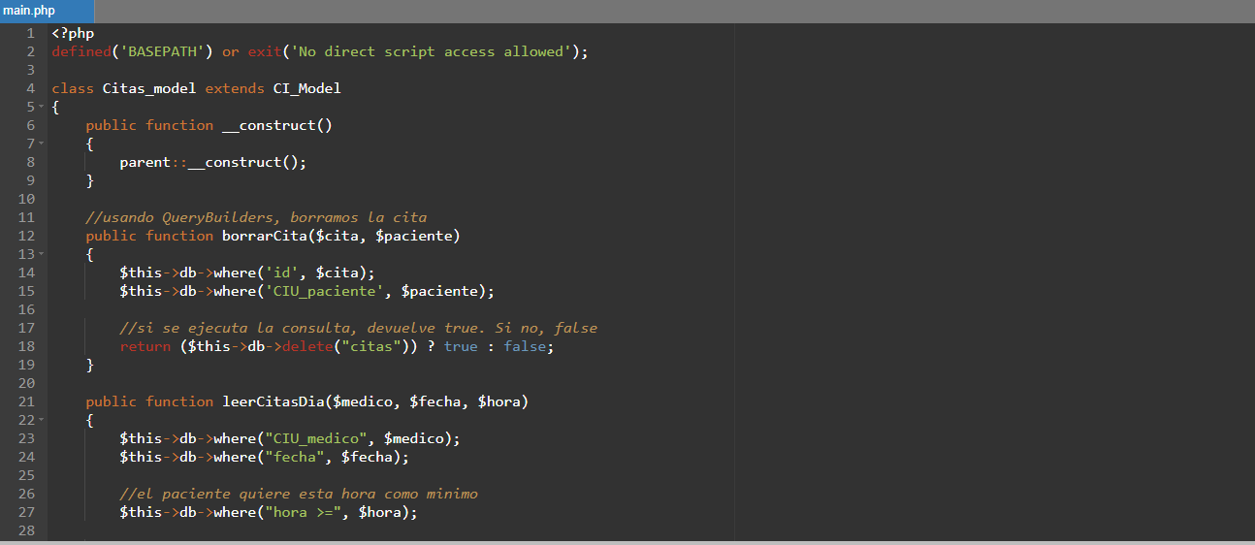

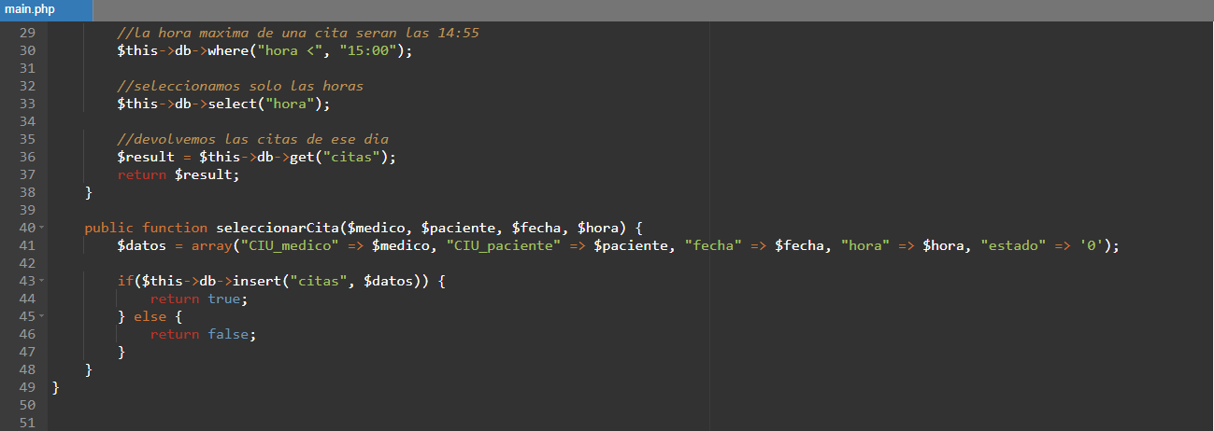

**Result**:

Thus, the details of architectural design/framework/implementation along with the screenshots were provided.

**Conclusion**:

It is a web-based application which assists staff, doctors and patients in managing their services in an easy, convenient and effective way.

The concept of web-based application here plays a vital role in the development of an effective system for managing health care. The proposed application is aimed at creating a friendly working environment for any health care canter and overcoming the disadvantages of the existing health care management system. This system is highly reliable and flexible in all aspects, making it easy to integrate new features and modules into the system in the future. Best project on E-Health Care Management System.